Real-Time Air Quality Monitoring and Forecasting System Using IoT and Machine Learning

A Capstone Project Documentation Presented to The College of Computer Studies PERPETUAL HELP COLLEGE OF MANILA

In Partial Fulfillment of the Requirements for the Degree BACHELOR OF SCIENCE IN INFORMATION TECHNOLOGY

Carpio, Ber Andrei S. Paderon, Raymond G. Christian, Felicano R. Bilangel, John Khail B.

May 2025
Table of Contents
Title Page |  | i
Table of Contents |  | ii
Chapter 1 – The Problem and Its Setting
 | Introduction | 1
 | Theoretical/Conceptual Framework | 3
 | Operational Framework | 7
 | Statement of the Problem | 9
 | Assumptions of the Study | 10
 | Scope and Delimitation | 11
 | Significance of the Study | 12
 | Definition of Terms | 15
Chapter 2 – Review of Related Literature
 | Review of Related Literature and Studies | 17
 | Synthesis of Reviewed Literature  Synthesis of Related Studies | 27  28
 | Gap/s Bridged | 29
Chapter 3 – Research Methodology
 | Research Design | 31
 | Project Design | 32
 | Project Development | 38
 | System Architecture | 45
 | Testing Procedures | 47
 | Sources of Data | 52
 | Population of the Study | 52
 | Instrumentation and Validation | 53
 | Evaluation and Scoring | 54
 | Data Gathering Procedure | 55
 | Statistical Treatment of Data | 56

CHAPTER I
THE PROBLEM AND ITS BACKGROUND
1.1 Introduction
Air pollution remains a critical global issue with far-reaching effects on human health, environmental sustainability, and climate change. It is a significant contributor to respiratory and cardiovascular diseases, as well as global warming (World Health Organization [WHO], 2021). Despite growing awareness, there remains a gap in public understanding and timely access to environmental data, especially in areas lacking advanced monitoring infrastructure. Conventional fixed monitoring stations, while widely adopted, are often expensive, limited in geographical coverage, and characterized by delayed data reporting, which can hinder timely interventions by both authorities and communities (Gupta et al., 2020). Furthermore, individuals frequently rely on subjective indicators such as visibility and smell, which are ineffective at detecting harmful pollutants at low concentrations.
The inadequacy of real-time air quality data and the limitations of traditional monitoring systems have underscored the need for more accessible, scalable, and accurate monitoring solutions. These gaps are particularly pronounced in under-resourced or remote areas where real-time environmental feedback is limited or unavailable. Additionally, the reliability of sensor data can be influenced by environmental factors such as humidity and temperature, necessitating proper calibration and robust data processing methods to ensure accuracy (Li et al., 2022).
Recent advancements in the Internet of Things (IoT), machine learning, and cloud computing technologies offer promising solutions to bridge these gaps. IoT-based sensors now enable continuous and real-time monitoring of key pollutants such as carbon monoxide (CO), nitrogen dioxide (NO₂), sulfur dioxide (SO₂), and particulate matter (PM2.5 and PM10) (Al-Hamadi & Soliman, 2021). These sensors, when paired with machine learning models, allow for accurate forecasting by analyzing historical data and identifying pollution trends (Chen & Liu, 2020). Cloud infrastructure further enhances the system by enabling scalable storage and real-time data access for stakeholders (Singh et al., 2023). Mobile applications complement these systems by offering real-time alerts and visualizations to the general public.
To address the challenges of limited coverage, delayed reporting, and accessibility, this study proposes the development of a Real-Time Air Quality Monitoring and Forecasting System using IoT and machine learning. The system integrates sensor-based air quality monitoring, predictive analytics, and cloud-based data management to ensure timely and reliable pollution assessment (Gupta et al., 2020). The goal is to deliver a scalable and efficient solution applicable to urban, industrial, and residential settings, particularly in regions where air pollution is a growing concern. Through this integration, the study aims to advance proactive air quality management and introduce a framework for intelligent environmental monitoring and forecasting.

1.2 Theoretical Framework
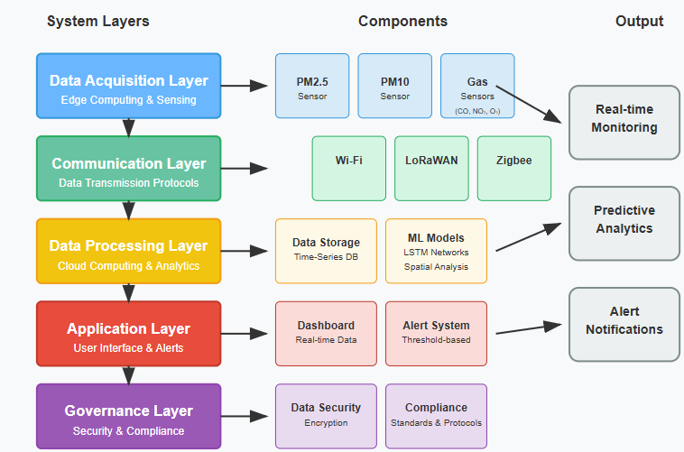
Figure 1: Integrated IoT-ML Air Quality Monitoring System Architecture
Figure 1 The theoretical foundation of this research is built upon an integrated Internet of Things (IoT) and Machine Learning (ML) framework that addresses the complex challenges of real-time environmental monitoring and predictive analytics. Figure 1 illustrates the comprehensive architecture developed specifically for this capstone project, demonstrating the systematic flow of information from data acquisition through processing to user interaction (Abdel-Basset et al., 2020).
The Internet of Things (IoT) framework is a critical component of the proposed "Real-Time Air Quality Monitoring and Forecasting System Using IoT and Machine Learning." It serves as the backbone of the system, enabling real-time data collection and seamless communication between various sensors, devices, and the cloud. The IoT architecture facilitates the deployment of sensors in strategic locations to detect and monitor air quality parameters such as PM2.5, PM10,
CO, NO2, and O3. These sensors are essential for capturing real-time data, which is then transmitted to a centralized system via wireless communication protocols such as Wi-Fi, LoRa, or ZigBee. Key Components of IoT in the System.
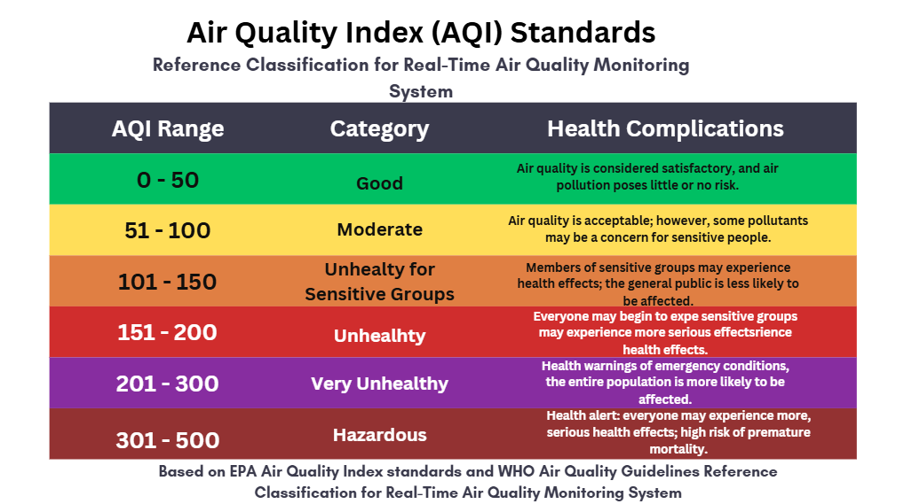
Figure 2: Air Quality Index (AQI) Standards
Figure 2 outlines the Air Quality Index (AQI) standards, a critical component of the proposed "Real-Time Air Quality Monitoring and Forecasting System Using IoT and Machine Learning." The AQI serves as the foundation for interpreting and classifying air quality data collected by the IoT sensors. It is a standardized scale that measures air pollution and communicates potential health risks to the public. The AQI categorizes air quality into various levels, each representing a range of pollutant concentrations and their associated health effects (World Health Organization [WHO], 2020).
The AQI is derived from the concentrations of key pollutants such as PM2.5, PM10, CO, NO2, and O3. These pollutants are measured in real-time by the sensors deployed in the system. The highest pollutant concentration value determines the overall AQI, ensuring that the system reflects the most hazardous air condition at any given time.
1.3 Conceptual Framework
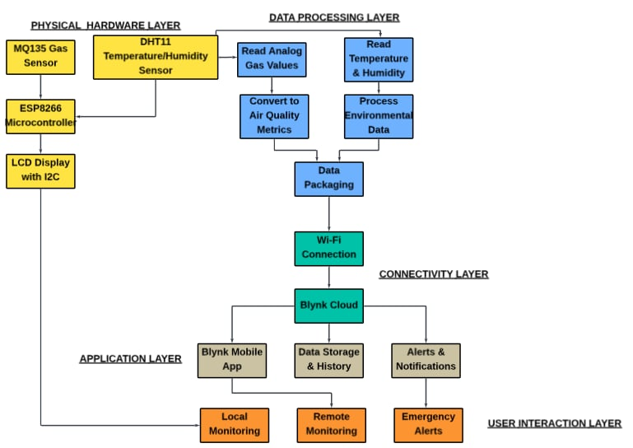

Figure 3: Air Quality Monitoring and Management System Flow
Figure 3 presents a layered conceptual framework for a Real-Time Air Quality Monitoring and Forecasting System. At the foundation is the Physical Hardware Layer, which includes the MQ135 gas sensor and DHT11 temperature/humidity sensor connected to an ESP8266 microcontroller. These components are responsible for collecting environmental data, while an LCD display provides local visual output of air quality readings in real time.
The Data Processing Layer handles the transformation of raw data into actionable information. It reads analog gas values and temperature/humidity data, converting them into air quality metrics and processed environmental indicators. This processed data is then packaged and transmitted through a Wi-Fi Connection, which serves as the bridge to the Connectivity Layer where Blynk Cloud manages the communication between hardware and application services. At the top of the framework, the Application Layer and User Interaction Layer deliver data to end users. Through the Blynk Mobile App, users can perform local and remote monitoring, access historical data, and receive real-time alerts and notifications. This layered structure ensures continuous air quality monitoring, effective data analysis, and timely user engagement for both awareness and emergency response.

1.4 Operational Framework
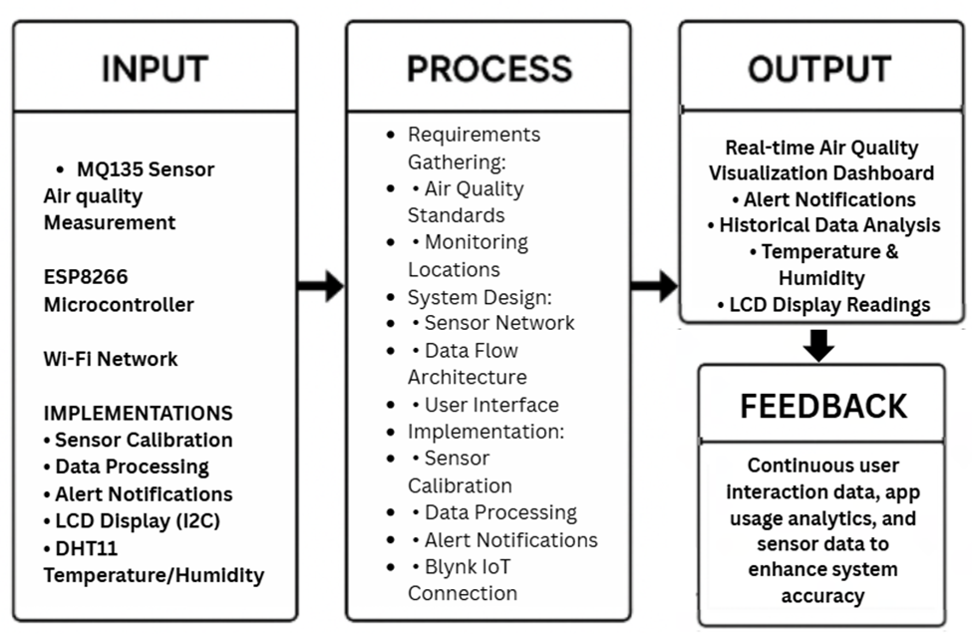
Figure 4: Operational Framework
The Air Quality Monitoring System utilizes an ESP8266 microcontroller as its processing core, combined with an MQ135 gas sensor for detecting air pollutants, a DHT11 sensor for temperature and humidity measurements, and an LCD display connected via I2C converter for local data visualization. The system is programmed using Arduino IDE with specialized libraries for each component and the Blynk IoT platform for remote monitoring capabilities. The process begins with configuring the hardware components and calibrating the MQ135 sensor to establish baseline readings for normal air quality conditions.
The system design incorporates a straightforward data flow where sensor readings are processed by the ESP8266, displayed locally on the LCD screen, and simultaneously transmitted via Wi-Fi to the Blynk cloud platform. Implementation includes writing Arduino code to handle sensor data acquisition, processing raw readings into meaningful air quality metrics, setting up notification thresholds, and establishing a reliable connection to the Blynk service. The output delivers real-time air quality information through dual channels: local display on the LCD screen for immediate viewing and a comprehensive Blynk dashboard accessible via smartphone or web browser. This dashboard provides visualizations of current air quality measurements, configurable alert notifications when pollutant levels exceed safe thresholds, and historical data tracking to identify patterns or changes in environmental conditions over time. The simple yet effective design makes this system ideal for home use, small offices, or educational demonstrations of IoT environmental monitoring.
The Air Quality Monitoring System utilizes an ESP8266 microcontroller as its processing core, combined with an MQ135 gas sensor for detecting air pollutants, a DHT11 sensor for temperature and humidity measurements, and an LCD display connected via I2C converter for local data visualization. The system is programmed using Arduino IDE with specialized libraries for each component and the Blynk IoT platform for remote monitoring capabilities. The process begins with configuring the hardware components and calibrating the MQ135 sensor to establish baseline readings for normal air quality conditions.
The system design incorporates a straightforward data flow where sensor readings are processed by the ESP8266, displayed locally on the LCD screen, and simultaneously transmitted via Wi-Fi to the Blynk cloud platform. Implementation includes writing Arduino code to handle sensor data acquisition, processing raw readings into meaningful air quality metrics, setting up notification thresholds, and establishing a reliable connection to the Blynk service. The output delivers real-time air quality information through dual channels: local display on the LCD screen for immediate viewing and a comprehensive Blynk dashboard accessible via smartphone or web browser. This dashboard provides visualizations of current air quality measurements, configurable alert notifications when pollutant levels exceed safe thresholds, and historical data tracking to identify patterns or changes in environmental conditions over time. The simple yet effective design makes this system ideal for home use, small offices, or educational demonstrations of IoT environmental monitoring.
1.5 Statement of the Problem
This research aims to develop a Real-Time Air Quality Monitoring and Forecasting System utilizing IoT-based sensors and machine learning algorithms to enhance air quality monitoring by providing real-time pollution data and predictive insights. The system is designed to support proactive measures that mitigate environmental and health risks caused by air pollution. Specifically, this study seeks to answer the following sub-problems:
- What are the challenges of the current air quality monitoring systems in the Philippines?
- What technology and machine learning algorithm can be used to improve the real-time collection, processing, and forecasting of air quality data?
- What data architecture and system features such as real-time alerts, geolocation mapping, and predictive analytics are essential for addressing air pollution challenges effectively?
- What features and functionalities should be included in a real-time air quality monitoring and forecasting system to enhance detection accuracy, user alerts, and automated response compared to traditional air quality monitoring methods?
- What is the level of effectiveness of the developed air quality monitoring and forecasting system based on ISO 25010 standards, as evaluated by IT specialists, in terms of: (1) Usability – Learnability, Operability, User Interface Aesthetics, Accessibility; (2) Reliability – Maturity, Availability, Fault Tolerance, Recoverability; (3) Security – Confidentiality, Integrity, Non-repudiation, Accountability, Authenticity?
- What extent does the system achieve user acceptance based on ISO 25010 criteria, particularly in the areas of: (1) Functional Suitability – Functional Completeness, Functional Correctness, Functional Appropriateness; (2) Performance Efficiency – Time Behavior, Resource Utilization, Capacity; (3) Usability – Learnability, Operability, User Interface Aesthetics, Accessibility; (4) Reliability – Maturity, Availability?
Assumptions of the Study
- The study assumes that the institution or organization implementing the air quality monitoring and forecasting system has the necessary technological infrastructure to support its deployment, including reliable internet connectivity, IoT device integration, and data storage solutions.
- It is assumed that the data gathered from IoT-based sensors is accurate and consistent, enabling reliable forecasting and timely environmental interventions.
- The machine learning algorithms employed are assumed to be capable of accurately processing environmental data and generating meaningful predictive analytics related to air quality trends.
- It is assumed that stakeholders including local government units, environmental agencies, and the public are receptive to using the system for accessing real-time air quality data and forecasts.
- The system is assumed to be user-friendly and accessible to both technical and non-technical users, with minimal training required for effective interaction.
- It is assumed that the deployment of the system will lead to increased environmental awareness and more informed decision-making among users regarding pollution mitigation.
- The study assumes that the data collected will be effectively used to identify pollution trends, assess community needs, and guide evidence based environmental policies and health-related actions.
1.6 Scope and Delimitation
Scope
This research focuses on the development of a Real-Time Air Quality Monitoring and Forecasting System that integrates IoT-based sensors and machine learning algorithms. The primary objective is to provide real-time monitoring of key air pollutants, including carbon monoxide (CO), nitrogen dioxide (NO₂), sulfur dioxide (SO₂), and particulate matter (PM₂.₅ and PM₁₀). The system will also generate predictive insights, helping users make proactive decisions related to environmental health and safety.
The system is designed for urban and industrial environments, where air pollution is a growing concern. It incorporates IoT sensors to collect environmental data continuously and utilizes machine learning models to analyze trends in air quality and forecast future conditions. A cloud-based platform, accessible via mobile and web applications, will allow individuals, local governments, and environmental agencies to view real-time data, receive alerts, and make informed decisions based on forecasts and geolocation-specific insights.
Delimitation
While this study offers a wide range of potential applications, it is limited in several key aspects. First, it focuses solely on the monitoring and forecasting of air quality and does not examine the short-term or long-term health effects of exposure to pollutants. The evaluation and implementation of the system are confined to selected geographic areas, meaning that its performance and findings may not be representative of conditions in other locations. The machine learning techniques applied in this study are limited to a predefined set considered most appropriate for the project’s scope and data characteristics; thus, the study does not explore the full breadth of available algorithms.
Additionally, while the system is intended to support environmental awareness and decision-making, it is not designed to formulate environmental policy or enforce regulations. Lastly, although privacy and data management are considered in the system’s design, this research does not provide a detailed legal or cybersecurity analysis, as these areas fall outside the primary focus of the study.
1.7 Significance of the Study
Air pollution continues to be a significant global challenge, affecting the health and quality of life of millions of people worldwide. However, many individuals and communities still lack real-time access to air quality data that could help them make informed decisions regarding their health and environment. This study aims to address this gap by developing a Real-Time Air Quality Monitoring and Forecasting System using IoT sensors and machine learning techniques. This research will provide significant benefits to various stakeholders, including individuals, communities, public health organizations, policymakers, and urban planners.
To Individuals and Communities
The real-time updates and forecasts provided by the system will allow individuals and communities to become more aware of the air quality in their environment. This knowledge will enable them to plan outdoor activities, especially in areas prone to high pollution levels, and minimize their exposure to harmful pollutants. People with respiratory conditions such as asthma will particularly benefit from the ability to avoid areas with unhealthy air quality, potentially improving their health outcomes.
To Public Health
Reliable and real-time air quality data is crucial in understanding the impact of air pollution on public health. By using this data, health organizations can track pollution trends, issue timely warnings, and provide advice on actions to take during periods of high pollution. This can help prevent respiratory diseases, cardiovascular problems, and other health conditions associated with air pollution, particularly in vulnerable populations.
To Smart Technology and Environmental Innovation
This study underscores the importance of integrating IoT sensors and machine learning to monitor environmental quality. By combining these technologies, the study demonstrates how innovative solutions can address complex, real-world problems like air pollution. The system is also a step toward the development of smart cities, where data-driven technologies help to monitor and improve the urban environment, fostering a sustainable future.
To Policymakers and Urban Planners
Governments and urban planners rely on accurate, real-time data to make informed decisions about environmental regulations and urban development. This system provides the tools needed for effective policymaking, allowing decision-makers to monitor air quality, enforce emission standards, and design healthier public spaces. The insights generated from the system can assist in developing strategies for pollution control and improving the quality of life for urban residents.
To the General Public
Unlike traditional, expensive air quality monitoring systems, this research aims to create an affordable and accessible system that delivers real-time air quality data to the public. By offering this information through mobile and web platforms, the system empowers individuals and communities to take proactive steps in managing their health and environment. It also promotes greater public awareness of air quality issues, encouraging collective action to improve air quality.
To Future Researchers
This study provides valuable insights and serves as a foundation for future research in environmental science, artificial intelligence, and IoT applications. The data collected and the methodologies developed can be adapted for other environmental monitoring applications, such as tracking temperature, humidity, and carbon emissions. The system also offers a model for integrating real-time data collection, analysis, and forecasting into various fields of study, opening new opportunities for innovation.

1.8 Definition of Terms
The following terms are defined in the context of this study, "Real-Time Air Quality Monitoring and Forecasting System Using IoT and Machine Learning," to provide clarity and enhance understanding of the key concepts and technologies discussed throughout the research.
Air Quality Monitoring
The systematic process of measuring the levels of airborne pollutants such as particulate matter (PM2.5, PM10), carbon dioxide (CO₂), and nitrogen dioxide (NO₂). In this study, monitoring is performed using real-time data from IoT-based sensors.
Air Quality Index (AQI)
A numerical scale used to communicate the level of air pollution in a specific area, with standardized color-coded categories that indicate the associated health risks.
Internet of Things (IoT)
A platform that uses cloud computing to store, process, and deliver air quality data collected by IoT sensors. It enables centralized access for users such as environmental agencies, policymakers, and the general public via web or mobile interfaces.
Machine Learning (ML)
Interconnected groups of IoT-based sensors that gather environmental data such as pollutant levels, temperature, and humidity. These networks ensure continuous, location-specific monitoring and support predictive analysis.
Internet of Things (IoT)
A network of physical devices embedded with sensors and software that communicate through the internet. In this study, IoT enables real-time data collection and transmission from air quality sensors to cloud platforms.
Sensor
A unit composed of environmental sensors and a microcontroller that collects and transmits air quality data. These nodes form the backbone of the data acquisition system.
Cloud
The use of cloud computing platforms to store, process, and visualize sensor data. In this project, cloud services facilitate data presentation and remote accessibility.
Python
Python is a high-level, interpreted programming language that is known for its simplicity, readability, and versatility. Python emphasizes code readability, allowing developers to write clear and concise code. In the context of the Real-Time Air Quality Monitoring and Forecasting System Using IoT and Machine Learning, Python plays a crucial role in processing and analyzing real-time environmental data collected through IoT devices, supporting machine learning models for predictive analytics and air quality forecasting.

CHAPTER II
Review of Related Literature
This chapter investigates the impact of IoT, machine learning, and real-time data processing on air quality monitoring and forecasting, drawing from local and international research. It explores IoT-based sensor networks, machine learning applications, predictive analytics, and system scalability, synthesizing findings to identify gaps and propose bridges through the Real-Time Air Quality Monitoring and Forecasting System, a scalable solution for environmental management.
IoT-Based Air Quality Monitoring Systems
The integration of the Internet of Things (IoT) has revolutionized air quality monitoring by enabling faster, cost-effective data collection through wireless sensor networks (WSN). A low-cost air quality monitoring system, developed using Arduino Leonardo and various sensors (measuring CO, PM2.5, PM10, temperature, and humidity), demonstrated competitive pricing at Php 17,605 compared to the Php 3,000,000 Differential Optical Absorption Spectroscopy (DOAS) system used by regulatory agencies. Statistical validation confirmed that the data collected were not significantly different from standard systems, establishing the system's reliability. IoT integration through Acer Cloud Professor allowed real-time data access via mobile, enhancing public accessibility. However, the study had limitations, such as excluding critical pollutants like O₃, NO₂, and SO₂, and the need for sensor calibration to improve accuracy. It also noted concerns about the system's long-term reliability, power efficiency, and scalability. Future improvements should address expanding pollutant detection, testing under different conditions, exploring alternative IoT platforms, and integrating renewable energy sources, which would increase the system’s scalability and accessibility for global communities (Cruz et al., 2019).
The role of IoT-based decision support systems has revolutionized poultry farming by improving environmental monitoring through real-time data visualization and early detection of anomalies. Several studies have documented the effectiveness of sensor networks and web platforms in optimizing poultry micro-climate conditions. In this study, both wired (ESP32-based) and wireless (LoRa-based) sensor networks were developed and deployed for monitoring harmful gases (NH₃, CO₂, H₂S), microclimatic parameters (temperature, humidity, wind velocity), and air quality (PM10, PM2.5), with negligible differences in the accuracy of both networks. High congruence with existing studies highlights the significance of real-time monitoring and decision support. However, some limitations were noted, such as the absence of automatic control measures, leaving environmental conditions largely reliant on manual intervention. Researchers in India also identified issues with the calibration of these systems, noting slight discrepancies in readings between different poultry house locations. Network stability, particularly with LoRa-based modules, remains a challenge due to interference from construction materials in enclosed spaces. Furthermore, scalability concerns arose, as the systems were only tested in two poultry houses, and performance in larger structures with multiple monitoring points remains unverified. Despite these drawbacks, the study contributes to the growing body of literature on IoT-based environmental monitoring and lays the foundation for future improvements in automation, sensor accuracy, and scalability (Rogers et al., 2023).
Indoor air quality monitoring IoT systems collect real-time data on indoor pollutants such as VOCs, CO, CO₂, aerosols, temperature, and humidity (Jo et al., 2020). The integration of cloud computing enables building managers to access, gather, and analyze data from various systems, improving decision-making and optimizing the operations of ventilation and heating systems. This approach ensures energy efficiency and allows users to receive timely notifications to take corrective actions for improving indoor air quality. The reliability of these systems has been empirically validated in areas exposed to outdoor air. However, several limitations persist, including the need for long-term validation to ensure sensor accuracy and performance over time, as initial tests have only confirmed short-term reliability. Cloud-dependent systems raise concerns about data privacy, security, and operational costs, as well as the lack of automated responses for immediate remedial actions. Additionally, periodic calibration and maintenance of the sensors add operational complexity due to the costs associated with potential data inaccuracies. Scalability is also a concern, requiring further testing to evaluate the efficiency of the platform in large-scale environments with high data streams. Future research should address automated systems, end-to-end reliability, cloud-optimized data processing, and security challenges to improve the robustness of air quality monitoring systems.
The monitoring of indoor air quality (IAQ) has gained significant attention with the adoption of wireless communication technologies and IoT-based solutions that allow for real-time data collection and analysis in residential, commercial, and institutional settings. Common communication technologies like Wi-Fi, ZigBee, Bluetooth, and LoRa offer distinct advantages related to power consumption, data transmission range, and cost-effectiveness. Many IAQ monitoring systems have incorporated smart features, such as integration with HVAC systems and cloud-based analytics, to improve air quality control and predictive analysis. Despite these advancements, challenges remain, including high implementation costs, interoperability between various communication technologies, and limited optimization for emerging standards like 5G. Data security and privacy concerns are largely unresolved, with some systems employing weak encryption and authentication protocols. Furthermore, energy consumption is a significant limitation for Wi-Fi and mobile network systems, which require substantial power resources for continuous operation. Research and development in IAQ monitoring continues to face the challenges of optimizing existing systems and ensuring sustainability over extended periods. The success of these technologies in improving indoor air quality will depend on overcoming these challenges by creating more economical, energy-efficient, and secure IAQ monitoring solutions (Zhao et al., 2022).
Several ventilation strategies, such as fresh air, displacement ventilation, and personalized ventilation, are aimed at minimizing viral transmission in enclosed spaces, although they require compromises in energy expenditure and thermal comfort. Air filtration and purification methods, including HEPA filters and electrostatic precipitators, have also been considered for capturing airborne viruses, thereby reducing the risk of infection in poorly ventilated areas. However, objective data on the real-life performance and cost-benefit of these strategies is lacking. Conflicting results regarding the impact of weather conditions such as temperature, humidity, wind speed, and rainfall on virus transmission highlight the need for more controlled investigations. The current knowledge on indoor air quality (IAQ) and virus transmission is highly situational, raising concerns about its broader applicability. Moreover, there remains a significant challenge in designing sustainable ventilation solutions that balance energy efficiency. Comprehensive policies and further research are needed to enhance IAQ and develop effective strategies for reducing airborne diseases in various real-life settings (Nair et al., 2022).
Sensor Technologies for Air Pollution Detection
Air pollution is a significant environmental and public health issue, contributing to respiratory disorders, heart diseases, and climate change. A study titled Environmental and Health Impacts of Air Pollution: A Review (2020) by the Laboratory of Hygiene and Environmental Protection at Democritus University of Thrace, Greece, discusses the effects of pollutants such as particulate matter (PM), nitrogen oxides (NOx), and sulfur dioxide (SO₂), particularly on vulnerable groups like children, the elderly, and individuals with pre-existing health conditions. The report highlights the connection between increased air pollution and global warming, deteriorating air quality, and extreme weather events. Despite advances in emission control technologies and regulatory policies, pollution remains a persistent issue, particularly in rapidly urbanizing and industrializing regions. The study emphasizes the need for stronger international collaboration, stricter environmental regulations, and investment in clean energy solutions to address air pollution's impacts. However, the research has limitations, such as reliance on existing databases with geospatial and temporal constraints, making it challenging to establish a direct causal link between pollutants and health effects, as well as neglecting emerging pollutants like microplastics and volatile organic compounds (VOCs). Given the study’s publication in early 2020, the ongoing pandemic and subsequent policy and technological changes may influence pollution trends. The review stresses the urgency to update data and develop innovative pollution control strategies to address the long-term implications of air pollution on public health and the environment comprehensively (Laboratory of Hygiene and Environmental Protection, 2020).
Zhao et al. (2020) provide a comprehensive review of the use of Internet of Things (IoT) technologies for personal air pollution prevention, highlighting the benefits of IoT-based solutions over traditional air quality monitoring systems. While traditional systems are more accurate, they are expensive and limited in spatial coverage. In contrast, IoT-based methods offer real-time, cost-effective, and scalable solutions that improve spatial data collection for air quality monitoring. The study presents an architecture integrating RFID, Machine-to-Machine (M2M) communication, sensor networks, and cloud-based platforms to enhance decision-making and air quality management. Case studies demonstrate the success of IoT monitoring tools in providing timely data for policymakers and the public. However, challenges include the reliability of low-cost sensors, affected by environmental factors like humidity and temperature, and issues related to data security and poor connectivity in remote areas. High initial infrastructure costs also limit widespread adoption, while the effectiveness of these systems depends on government policies and stakeholder collaboration. Despite these obstacles, the study concludes that IoT technologies offer promising solutions for revolutionizing air pollution monitoring and improving global air quality (Zhao et al., 2020).
The journal Sensors by MDPI (2025) presents a Topical Collection on "Sensors for Air Quality Monitoring," focusing on the development and application of low-cost, high-precision sensors for air quality evaluation. The research suggests that these sensors can complement traditional monitoring systems by offering reliable, cost-effective, and scalable solutions for real-time air quality assessment. The collection examines sensor calibration techniques and highlights improvements in data accuracy and pollution hotspot identification. Moreover, the integration of sensor networks with Internet of Things (IoT) platforms enables real-time monitoring, predictive analysis, and cloud-based decision support for air quality management. Contributions from fields like physics, chemistry, environmental science, and IT enhance the understanding of pollution sources and their impact. The use of artificial intelligence (AI) and machine learning further refines data processing and aids decision-making. However, the collection also addresses several limitations, such as challenges with sensor calibration, scalability issues due to varying environmental conditions, and data security concerns. Additionally, the reliance on hardware innovations without sufficient attention to policy and implementation challenges may hinder large-scale adoption. While the collection provides valuable insights for researchers, policymakers, and environmental agencies, addressing concerns related to sensor accuracy, data security, and policies will be crucial for the long-term success of air quality monitoring solutions (MDPI, 2025).
The article "How to Establish Standards and Monitor Outdoor Air Quality" by C40 Knowledge Hub (2019) offers a structured guide for cities to create effective air quality management systems aligned with health standards, such as those from the World Health Organization (WHO). The study discusses strategies like strategic sensor siting for accurate pollutant measurement (PM2.5 and ozone) and the use of air quality data in public information campaigns to raise citizen awareness and encourage engagement. It emphasizes the importance of policy interventions and cross-sector collaboration to set clean air standards and improve public health outcomes. However, the research highlights several limitations, including unequal air quality monitoring infrastructure in low-income areas and challenges related to sensor placement accuracy, which can be affected by weather, urban geography, and traffic patterns. Furthermore, despite advocating for public engagement, the study notes difficulties in achieving widespread citizen awareness and behavior change, particularly in communities with limited digital access. The success of policy interventions also depends on political commitment and regulatory enforcement, which varies by region. The study does not offer empirical evidence or longitudinal case studies to demonstrate the effectiveness of these strategies across different urban contexts. Nevertheless, the research provides valuable insights for policymakers, environmental agencies, and urban planners working to improve air quality management and monitoring strategies (C40 Knowledge Hub, 2019).
Concas et al. (2021) conducted an extensive review of low-cost air quality monitoring methods and sensor calibration, positioning them as viable alternatives to conventional high-cost regulated monitoring stations. While traditional monitoring systems provide accurate data, their limited deployment restricts spatial coverage. In contrast, low-cost sensors can be strategically placed for real-time, localized monitoring, especially in urban areas affected by traffic, industrial emissions, and meteorological changes. The study highlights the use of machine learning, in-field calibration, and data fusion techniques to improve the accuracy of these sensors and reduce inconsistencies. It also underscores the importance of interdisciplinary collaboration among environmental scientists, engineers, and policymakers to optimize the integration of low-cost sensors into established monitoring networks. Despite these advantages, the study identifies several challenges, including environmental interferences (e.g., temperature, humidity, and cross-pollutants) that can affect sensor accuracy. Sensor calibration and data reliability remain significant obstacles, requiring ongoing corrections to maintain accuracy. Issues with data integration, standardization, and comparability within regulatory frameworks, as well as concerns about the long-term sustainability and cost-efficiency of large-scale sensor deployments, particularly in resource-limited settings, are also discussed. Despite these limitations, the study concludes that low-cost sensors hold promise for enhancing air quality monitoring and supporting data-driven policy decisions (Concas et al., 2021).
Machine Learning Algorithms for Air Quality Prediction
Francisco (2024) proposed an air quality monitoring system using IoT technology to address increasing air pollution in Manila. This system utilizes sensors to monitor pollutants such as carbon monoxide (CO), nitrogen oxides (NOx), and benzene, generating real-time data. The study emphasizes the continuous monitoring capabilities, identification of pollution hotspots, and cloud-based data storage that enhances accessibility for both authorities and the public. This system is expected to support data-driven environmental policies and promote public awareness and engagement in pollution control efforts. However, the study identifies several challenges, including the potential inaccuracy of low-cost sensors that require frequent calibration, network and connectivity issues hindering real-time data transmission, and limited sensor coverage that may not fully represent pollution levels across the city. Additionally, environmental factors like temperature and humidity could affect sensor performance, requiring expert interpretation of the data for effective policy development. Despite these challenges, the study concludes that IoT technology holds significant potential to improve air quality monitoring and urban environmental management (Francisco, 2024).
Corpus (2023) developed an air quality monitoring system designed for source-receptor analysis, aimed at tracking pollutants and tracing their sources in various locations across the Philippines. The system uses IoT-based sensors and machine learning algorithms to monitor pollutants such as carbon monoxide (CO) and nitrogen dioxide (NO₂) in real time, enabling the detection of pollution trends. This data can aid policymakers in making informed environmental decisions and public health interventions. The study highlights the potential of integrating IoT and AI to enhance air quality assessment and urban planning. However, several limitations were identified, including sensor sensitivity and accuracy issues, as low-cost IoT sensors require frequent calibration for reliable data. Additionally, the system’s effectiveness depends on the volume and quality of the data collected, and limited sensor coverage could impact the comprehensiveness of pollution analysis. Environmental factors like weather conditions and wind patterns may also influence pollutant dispersion and the accuracy of source identification. The study also emphasizes the need for sufficient computational power and stable internet connectivity for effective data processing and transmission. Despite these challenges, the study concludes that advanced air quality monitoring technologies show promise in providing valuable insights for developing targeted pollution mitigation strategies (Corpus, 2023).
Culpa et al. (2021) developed an air quality monitoring system linked to a cloud platform to track gaseous pollutants in urban environments. The system utilizes a network of wireless sensors to measure carbon monoxide (CO) and nitrogen oxides (NOx), transmitting the data via GSM technology to provide real-time monitoring and online dashboard access, allowing the public to view pollutant levels. The study concludes that the system could foster public awareness and encourage local governments to create evidence-based air quality policies. Furthermore, it demonstrates that IoT-based monitoring is cost-effective and scalable, making it a viable option for cities with similar pollution challenges. However, the study identifies several limitations, including sensor accuracy concerns, as low-cost sensors require frequent calibration to maintain reliable data. The system’s reliance on GSM technology also exposes it to disruptions, particularly in areas with poor signal coverage. Additionally, the system only detects CO and NOx, potentially overlooking other harmful pollutants such as particulate matter (PM2.5 and PM10). Environmental factors like temperature, humidity, and atmospheric pressure can also affect sensor readings and reduce data accuracy. Moreover, while scalability requires infrastructure and funding, these could pose implementation barriers. Despite these challenges, the research demonstrates the potential of real-time cloud-linked IoT systems for enhancing air quality monitoring and supporting data-driven environmental management (Culpa et al., 2021).
The Robust Optical Aerosol Monitor (ROAM), developed by researchers at the University of the Philippines Diliman in 2021, is the first locally manufactured air quality monitoring device. Initially deployed in Agoncillo, Batangas, and Alfonso, Cavite, following the 2020 Taal Volcano eruption, ROAM measures particulate matter (PM) in real time and transmits data through a mobile application, allowing communities and disaster responders to monitor pollutant levels and take appropriate actions. The study highlights ROAM's role in providing real-time environmental data, demonstrating how local technology can enhance air quality monitoring and disaster preparedness. While ROAM could be adapted for broader air quality applications beyond volcanic eruptions, it has limitations, such as its focus on PM measurements, which may overlook other harmful pollutants like sulfur dioxide (SO₂) and carbon monoxide (CO). Additionally, the device requires regular calibration, which may become challenging in post-disaster scenarios where mobile connectivity is limited. The long-term performance of ROAM remains uncertain, as it was originally designed for a specific event. Despite these challenges, the study underscores the value of localized air quality monitoring and the potential of Philippine-made technology in addressing pollution and improving disaster response efforts (University of the Philippines Diliman, 2021).
The partnership between the Philippine Space Agency (PhilSA) and the Korea International Cooperation Agency (KOICA) aims to improve air quality monitoring in the Philippines through the use of both ground and satellite technologies. This system, which utilizes Korea's Geostationary Environment Monitoring Spectrometer (GEMS) for hourly tracking of air pollutants and ground-based Pandora instruments for real-time validation, enhances the country's ability to monitor air quality over large areas. The study underscores the importance of international collaboration in tackling air pollution and supporting evidence-based environmental policy-making. However, several limitations were identified, including the dependence on satellite data, which can be affected by cloud cover and other atmospheric conditions, leading to less accurate measurements. Additionally, the limited number of Pandora instruments restricts the ability to validate air quality nationwide. The integration of satellite and ground-based data also presents challenges related to calibration and consistency, requiring specialized expertise. Sustainability concerns were raised, as continuous infrastructure maintenance and funding are necessary for long-term operation. Furthermore, although the data collected is valuable, bureaucratic processes may delay the implementation of policies based on this information. Despite these limitations, the study represents significant progress in air quality monitoring and the development of environmental policies in the Philippines (PhilSA & KOICA, 2023).
Air Pollution on Public Health
Air quality monitoring involves using statistical learning models to predict and control harmful air pollutants such as CO, CO₂, NO₂, SO₂, and particulate matter, which pose serious health risks. These models aid decision-makers in managing pollution and are crucial for regulatory efforts, particularly in India. Regular monitoring helps identify pollution sources and levels, promoting healthier environments. However, the study is limited by its focus on India and lacks consideration of emerging pollutants and climate change impacts. Despite this, it highlights the importance of predictive modeling and regulation in air pollution control.
Aserkar et al. (2020–2024) developed a low-cost and efficient IoT-enabled air quality monitoring system designed for smart cities. The system utilizes the ESP-WROOM-32 microcontroller integrated with sensor modules such as PMSA003, MICS-6814, and MQ-131 for accurate detection of pollutants including ammonia, carbon monoxide, nitrogen dioxide, PM2.5, and ozone. It connects to Amazon Web Services for real-time tracking, analytics, and cloud data storage, achieving a high accuracy with an RMSE of 3.7656. While the system is effective for continuous monitoring and supports proactive public health initiatives, limitations include the need for dense sensor deployment, geographic coverage challenges especially in rural areas environmental sensitivity of sensors, dependency on stable internet connectivity, and issues of scalability, cost, maintenance, and data security. Despite these drawbacks, the approach presents significant potential for improving urban air quality and public health (Aserkar et al., 2020–2024).
Dhope et al. (2020) investigated the relationship between air pollution, urbanization, and industrialization through the development of a Real-Time Air Quality Surveillance & Forecasting System (RTAQSFS) for urban centers like Pune, India. The system integrates machine learning algorithms with electronic sensors (MQ135, MQ7, MQ131) to monitor pollutants such as CO₂ and ammonia. The study evaluated several algorithms, including Linear Regression, Ridge Regression, Lasso Regression, Decision Tree, and Random Forest, with Random Forest achieving the highest performance (R² = 99.9%) and lowest RMSE, making it the most effective for air quality forecasting. This highlights the value of combining IoT and machine learning for sustainable pollution monitoring and informed policymaking. However, limitations include sensitivity of sensors to environmental conditions, dependence on real-time data accuracy, potential limitations in applying the system beyond Pune, and challenges in scaling to larger or more complex cities. Nonetheless, the study demonstrates the strong potential of predictive models in real-time air quality management (Dhope et al., 2020).
Kitchilan (2022) explores the issue of urban air pollution stemming from vehicular emissions, industrial activity, and manufacturing, which contributes to harmful pollutants such as particulate matter, carbon monoxide, and ozone. The study presents a low-cost, real-time air quality monitoring system utilizing Arduino-based IoT sensors, calibrated for reliability. Over a three-month period, collected data was used to develop a PM2.5 forecasting model using the Random Forest algorithm, which outperformed alternatives like linear regression and decision trees. The findings emphasize the effectiveness of integrating IoT and machine learning for improved air quality forecasting and public health management. However, the study acknowledges limitations such as the dependency on accurate sensor calibration, limited duration of data collection that may not reflect long-term trends or seasonal variations, and reduced generalizability to regions with different pollution profiles. Additionally, challenges related to scaling the system to larger or more complex urban environments and adapting to unpredictable environmental changes are noted. Despite these issues, the study demonstrates the strong potential of low-cost, real-time air quality monitoring through IoT and machine learning integration (Kitchilan, 2022).
Reddy (2020) introduces a real-time air quality forecasting system that combines data from air quality sensors, meteorological parameters, and machine learning algorithms such as Random Forest and Decision Trees. The system monitors pollutants like particulate matter (PM), nitrogen dioxide (NO₂), and sulfur dioxide (SO₂), alongside environmental factors including temperature, humidity, wind speed, and atmospheric pressure. Machine learning models trained on historical data enable high-resolution temporal and spatial forecasts. A user-friendly interface provides real-time predictions and alerts, allowing stakeholders such as environmental agencies and the public to take timely action. The study demonstrates the effectiveness of data-driven approaches in improving air quality forecasting and supporting public health. However, the accuracy of predictions relies heavily on the quality of historical data and proper sensor calibration. Additionally, unusual weather patterns can disrupt model accuracy, and scalability to larger or more complex urban areas remains a challenge. Despite these limitations, the system shows strong potential for enhancing air quality monitoring and environmental management (Reddy, 2020).
2.2 Synthesis of Reviewed Literature
The integration of Internet of Things (IoT) technologies has significantly improved air quality monitoring by enabling real-time, cost-effective data collection through sensor networks. Multiple studies demonstrate that low-cost IoT systems, such as those using Arduino, ESP32, and LoRa, are capable of reliably measuring pollutants like CO, PM2.5, PM10, NO₂, and VOCs, as well as environmental parameters such as temperature and humidity. These systems are often integrated with cloud platforms and mobile access, enhancing data availability for both policymakers and the public.
While promising, these systems face limitations including sensor calibration issues, network reliability, environmental interference, and limited pollutant detection scope. Long-term performance, scalability, and energy efficiency are also challenges. In specialized environments like poultry farms and indoor settings, IoT-based monitoring has shown benefits in optimizing air quality and ventilation, but automation and system integration are often lacking.
Studies also highlight the role of policy and regulatory frameworks in maximizing the impact of air quality monitoring. However, disparities in monitoring infrastructure, especially in low-income or remote areas, and concerns about data privacy and security remain unresolved. Despite these challenges, IoT and AI-driven monitoring systems are seen as crucial tools for supporting environmental management, improving public health, and informing data-driven policy decisions.
2.3 Synthesis of Related Studies
Several studies have looked into using technology to monitor the environment, especially by using IoT devices and machine learning to measure and predict air quality. These studies highlight the need for real-time data and accurate predictions to help solve air pollution problems. Researchers have created systems using IoT sensors that can track air pollutants like PM2.5, PM10, CO₂, and NO₂. These sensors send data to servers using small computers and wireless networks. This setup makes it easier to collect and share air quality information quickly and at a low cost. Other studies used machine learning methods like decision trees and neural networks to predict air quality based on past data. These tools can spot trends and give early warnings, helping people and governments make better decisions. Some systems also included websites or mobile apps to show air quality levels. These features help people understand and respond to pollution in their area.
In summary, past research proves that combining IoT and machine learning is effective for monitoring and forecasting air quality. These studies helped shape the design of this project. However, many existing systems don’t provide local predictions or easy access for users. This project aims to fill those gaps by offering real-time monitoring and forecasts that are useful and easy to understand.
2.4 Gaps and Bridges
- Gap Bridge 1: Development of a Low-Cost Air Quality Data Acquisition IoT-based System using Arduino Leonardo
Previous studies, such as Cruz et al. (2020), have demonstrated the viability of using low-cost microcontrollers like Arduino Leonardo for monitoring air pollutants such as CO, PM2.5, and PM10, along with temperature and humidity. However, these systems often exclude other critical pollutants like ozone (O₃), nitrogen dioxide (NO₂), and sulfur dioxide (SO₂), and are limited by fixed sampling locations, minimal scalability, and reliance on restricted platforms such as Acer Cloud Professor.
The current research addresses this gap by developing a more comprehensive and scalable IoT-based air quality monitoring system that incorporates additional pollutant sensors (O₃, NO₂, SO₂), utilizes flexible and widely supported microcontrollers like ESP8266 or Raspberry Pi, and integrates solar energy to promote sustainability. This approach allows deployment across multiple locations and improves system reliability, affordability, and accessibility for real-time environmental monitoring.

- Gap Bridge 2: Development of an IoT-Based Indoor Air Quality Monitoring Platform
Contemporary IoT platforms for indoor air quality monitoring offer real-time tracking of key environmental factors (VOCs, CO, CO₂, temperature, and humidity) and enable cloud-based access and energy-efficient operation. However, they often suffer from shortcomings such as dependency on cloud services raising concerns around data privacy and cost lack of automated responses to poor air quality, and a need for frequent sensor recalibration, which affects long-term reliability.
This study proposes a solution by designing an indoor air quality monitoring system that processes data locally using edge computing techniques, thereby reducing reliance on external cloud platforms. Additionally, the system is equipped with smart automation features such as alerts and activation of ventilation systems based on pollutant thresholds. Regular sensor recalibration protocols are also integrated to maintain accuracy over extended periods, ensuring long-term functionality and reliability.

CHAPTER III
METHODOLOGY
This chapter outlines the research methods employed in this study to develop a real-time air quality monitoring and forecasting system using IoT and Machine Learning. It covers the research design, system architecture, sources of data, study population, instrumentation and validation procedures, evaluation criteria, and data gathering techniques. Additionally, the chapter discusses the statistical treatment of data and ethical considerations taken into account during the research. It further highlights the data collection methods and the system architecture necessary to create an efficient air quality monitoring and forecasting solution.
  - Research Design
This study applied the Developmental Research Method to design and implement a Real-Time Air Quality Monitoring and Forecasting System using IoT and Machine Learning. The approach involved systematically designing, developing, and refining the system through prototyping and testing. The research identified key limitations in existing air quality monitoring systems, including high costs, geographic constraints, and delayed reporting, as well as the lack of predictive analytics and real-time data.

To address these challenges, the study proposed an integrated system with IoT sensors, cloud computing, and machine learning for real-time air quality monitoring and forecasting. The system’s effectiveness was tested through rigorous evaluations of sensor accuracy, data transmission reliability, machine learning forecasting, and the user interface. Feedback from users was incorporated to refine the design, ensuring a highly reliable and responsive solution.
The outcome was a more advanced and efficient air quality management system, surpassing traditional methods in accuracy and addressing air pollution concerns effectively.

  - Project Design

The development of an IoT-Based Air Quality Monitoring System aims to help solve environmental problems using technology. This system gives real-time air quality readings that can be seen both on a screen and through a mobile app. With this, monitoring air becomes easier and more affordable, removing the need for expensive tools while still giving helpful data about the air.

The development of the system started with choosing and preparing the right parts. In this phase, the researchers selected sensors and microcontrollers that could measure air quality and were also low-cost and easy to use. After that, the team connected the ESP8266 microcontroller to the Blynk IoT platform to make the data viewable on a phone. This led to the creation of the system’s program. Using sensor setup methods and wireless connection, the data was added into the system design. The process also included building the circuit, making the display for both LCD and mobile, and designing how the system works.

With a strong goal of helping people and the environment, this study focused on building an air quality monitoring system that can be used at home or in schools. With IoT and sensors, the system works like a small air monitoring station that gives live updates, shows information, and sends alerts about air conditions.

Also, the system was tested by users and experts. The test followed ISO25010 standards and looked at how well the system works, how easy it is to use, how reliable it is, and how fast it runs. The system was made to run all the time with little need for fixing, making it good for long use indoors.
Project Deliverables
(1) ESP8266 NodeMCU
(2) MQ135 Gas Sensor
(3) DHT11 Temperature and Humidity Sensor
(4) LCD Display with I2C Converter
(5) Arduino IDE experts.
(6) Blynk IoT Platform
According to Kumar et al. (2020), when building IoT air monitoring systems, it is important to choose the right parts. The MQ135 gas sensor was chosen because it can detect many harmful gases. The Blynk platform was used so users can see the air quality on their phones easily. This was based on studies showing more people want remote monitoring tools at home or in school, making the system useful for many users.
Research Methods and Instruments

The researchers used various methods to gather information and obtain significant data relevant to this study. This includes field data collection, surveys, and consultations with environmental experts to ensure the system’s functionality and accuracy.

Field Data Collection: The proponents used IoT-based environmental sensors deployed in various locations to gather real-time data on air quality parameters, such as PM2.5, PM10, CO2 levels, and temperature. This data was crucial for both immediate monitoring and future air quality predictions.

Survey Questionnaire: In addition to field data, the proponents used surveys to gauge the public's understanding of air quality and their needs for a forecasting system. The survey focused on gathering perceptions about the usability, reliability, and performance of the system from potential users, including local authorities, environmental groups, and individuals.

A Five-point Likert Scale was used for the analysis and interpretation of the responses, helping respondents assess their agreement or disagreement with statements about the system’s functionality and overall impact on health and environmental awareness. The answers gathered from the survey served as input in the evaluation of the system’s effectiveness and areas for improvement.

Table 1. Five-point Likert Scale Interpretation Table for System Functionality
Scale | Range | Interpretation
5 | 4.5 - 5.0 | Highly Functional
4 | 3.5 - 4.4 | Functional
3 | 2.5 - 3.4 | Neutral
2 | 1.5 - 2.4 | Slightly Not Functional
1 | 0 -1.4 | Not Functional
Table 2. Five-point Likert Scale Interpretation Table for Forecasting Performance Efficiency
Scale | Range | Interpretation
5 | 4.5 - 5.0 | Highly Functional
4 | 3.5 - 4.4 | Efficient
3 | 2.5 - 3.4 | Neutral
2 | 1.5 - 2.4 | Inefficient
1 | 0 -1.4 | Highly Inefficient

Table 3. Five-point Likert Scale Interpretation Table for System Reliability
Scale | Range | Interpretation
5 | 4.5 - 5.0 | Highly Functional
4 | 3.5 - 4.4 | Reliable
3 | 2.5 - 3.4 | Neutral
2 | 1.5 - 2.4 | Non-Reliable
1 | 0 -1.4 | Highly non-reliable

Table 4. Five-point Likert Scale Interpretation Table for IoT Compatibility
Scale | Range | Interpretation
5 | 4.5 - 5.0 | Highly Compatible
4 | 3.5 - 4.4 | Compatible
3 | 2.5 - 3.4 | Neutral
2 | 1.5 - 2.4 | Incompatible
1 | 0 -1.4 | Highly Incompatible

Table 5. Five-point Likert Scale Interpretation Table for User Usability of Monitoring System
Scale | Range | Interpretation
5 | 4.5 - 5.0 | Highly Usable
4 | 3.5 - 4.4 | Usable
3 | 2.5 - 3.4 | Neutral
2 | 1.5 - 2.4 | Unusable
1 | 0 -1.4 | Highly Unusable

Internet Research. This method was utilized by the researchers to collect relevant literature, technical documentation, and past studies related to air quality monitoring systems and forecasting technologies. The data gathered served as a guideline and reference throughout the development of the Real-Time Air Quality Monitoring and Forecasting System.
  - Project Development
The Real-Time Air Quality Monitoring and Forecasting System was developed using the Agile methodology, encouraging continual improvements based on testing and feedback. Integration of air quality monitoring, predictive analytics, and the user interface required implementation and evaluation of each capability in steps. This system approach, therefore, optimizes the system in terms of accuracy, reliability, and ease of use to prove an efficient air quality solution for monitoring and forecasting.

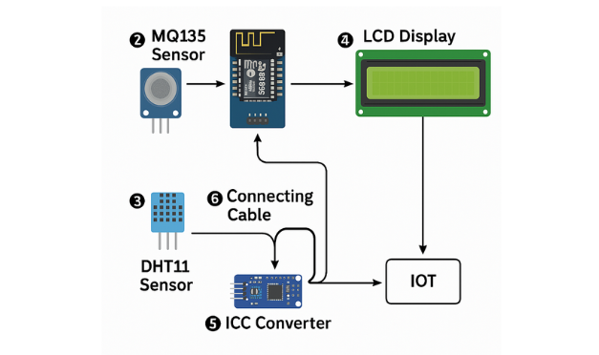
Figure 5: System Architecture of Command Control
Figure 5 illustrates the architecture of the Real-Time Air Quality Monitoring and Forecasting System. This diagram provides an overview of how the system components, including the IoT sensors, microcontroller, cloud server, machine learning models, and user interface, interact to achieve the system's objectives.

The IoT sensing devices sense the air quality levels located in the defined area. The sensors send the data to the microcontroller that gets the information processed and transmits it to the cloud server through IoT protocols. The machine learning models on the cloud server analyze the data for forecasting future air quality trends. These insights are then offered to users through a mobile application or web dashboard.

The architecture ensures all critical functions air quality monitoring, data transmission, predictive analytics, and user notifications work in unison as an efficient and automated air quality monitoring and forecasting system.

Gantt Chart

Table 6: Real-Time Air Quality Monitoring and Forecasting System Project Timeline
Real-Time Air Quality Monitoring and Forecasting System Project Timeline |  |  | Weeks
Deliverables | 1 | 2 |  | 3 | 4 | 5 | 6 | 7 | 8 | 9 | 10 | 11 | 12 | 13
Requirement Gathering & Feasibility Study
System Design & Architecture
Hardware Integration & Initial Development
Machine Learning Model Development
System Testing & Debugging
User Testing & Feedback
Finalization & Documentation
As outlined in Table 6, the implementation follows a structured 13-week timeline to ensure the system is developed efficiently and systematically. The process begins with Requirement Gathering & Data Collection (Weeks 1–3), during which the proponents gather air quality parameters, identify appropriate IoT sensors, and define system requirements for both monitoring and forecasting capabilities.
Next is the Sensor Integration and Calibration (Weeks 4–5), where the IoT devices are installed, configured, and tested to ensure accurate data transmission. Simultaneously, Analysis & System Design (Weeks 3–11) focuses on defining the data flow, communication between hardware and cloud infrastructure, and designing the user interface for real-time air quality visualization.
In Machine Learning Model Training and Evaluation (Weeks 6–11), collected environmental data is used to train and validate forecasting models that predict future air quality trends. This is followed by System Testing & Validation (Week 12), where the system undergoes rigorous testing for functionality, reliability, and performance efficiency.
Finally, User Acceptance Testing (Week 13) involves feedback collection from selected users such as students, faculty, and administrators, to evaluate usability and overall satisfaction, ensuring the system meets its intended goals prior to full deployment.
As shown in the timeline, the project spans thirteen (13) weeks, with the core development and design phases occupying the bulk of the schedule. The final weeks focus on evaluation and optimization, ensuring the system delivers accurate, reliable, and user-friendly air quality monitoring and forecasting features.
Implementation Plan
As shown in Table 7, the implementation of the Real-Time Air Quality Monitoring and Forecasting System begins with obtaining approval from the College Dean in Week 1, where the project’s objectives and expected, benefits are presented to secure authorization for development. From Weeks 2-4, the proponents focus on gathering the necessary hardware and software requirements through research, surveys, and consultations. Additionally, the integration of machine learning techniques for forecasting and real-time data analysis is studied to ensure the system’s predictive capabilities are accurate and effective.

Table 7. Implementation Plan
STRATEGY | ACTIVITIES | PERSON INVOLVED | DURATION
Approval from College Dean | Present the project objectives to the College Dean, finalize project scope, and receive approval. | Proponent, College Dean | 1 week
Requirement Gathering & Research | Research IoT-based air quality systems, identify components (ESP8266, MQ135, DHT11, LCD Display, I2C Converter, Connecting Cables), and finalize system requirements. | Proponents | 2 weeks
System Design | Plan system architecture, including sensor integration, data collection, real-time monitoring, and forecasting model design. | Proponents | 1 week
Hardware Integration & Initial Development | Assemble components (ESP8266, MQ135, DHT11, LCD Display with I2C Converter, Connecting Cables) and test hardware connections. | Proponents | 2 weeks
Machine Learning Model Development | Integrate and develop forecasting models using machine learning to predict air quality based on real-time data. | Proponents | 3 weeks

Software Development & Integration | Program the microcontroller (ESP8266) to collect data from sensors, transmit data to the cloud, and integrate the machine learning model for forecasting. | Proponents | 1 weeks
System Testing & Debugging | Test system components (sensors, microcontroller, cloud integration, and forecasting) for accuracy and performance. | IT Professionals, Proponents | 1 weeks
User Acceptance Testing & Feedback | Perform user acceptance testing (UAT) with users (faculty/admins), collect feedback for final adjustments. | Proponents, Users | 1 week
Finalization & Documentation | Finalize the system, document the project details, and prepare user manuals for deployment and maintenance. | Proponents | 1 week
TOTAL DURATION |  |  | 13 WEEKS
In Week 5, the documentation phase is initiated, which involves compiling technical specifications, system requirements, and research findings to ensure compliance with best practices and industry standards. Development begins in Weeks 6-11, where the system architecture, hardware integration, and machine learning model implementation are carried out. This stage also includes the development of the user interface and real-time monitoring functionality, ensuring a seamless user experience and accurate data processing.
From Weeks 11-12, system testing and evaluation are performed. IT professionals and project proponents test the system’s functionality, accuracy, and overall performance, addressing any issues that arise during this phase. Additionally, User Acceptance Testing (UAT) is conducted to gather feedback from stakeholders, ensuring the system is ready for real-world deployment.
Finally, in Week 13, the system is finalized, documented, and presented. This phase includes the deployment of the system, training for users, and preparing the system for real-time operation, ensuring smooth integration and use for monitoring and forecasting air quality.
  - System Architecture
Figure 6: System Architecture of the Air Quality Monitoring System Figure 1 illustrates the process of how the Air Quality Monitoring System operates. The system is designed to continuously monitor air quality parameters and provide both local and remote access to this vital environmental data. It utilizes an MQ135 gas sensor to detect various harmful gases including NH3, NOx, alcohol, benzene, smoke, and CO2, while a DHT11 sensor simultaneously monitors temperature and humidity levels. The ESP8266 microcontroller serves as the central processing unit, receiving data from both sensors and analyzing the readings in real-time. Upon collecting the sensor data, the ESP8266 processes the information and determines if the air quality parameters are within acceptable ranges.
The processed data is then routed to two output channels simultaneously. For local monitoring, the system incorporates an LCD display connected via an I2C converter, which provides immediate visual feedback on current air quality conditions, temperature, and humidity levels. This allows users to quickly assess the environmental conditions in their vicinity. Concurrently, the ESP8266 leverages its Wi-Fi capabilities to transmit the data to the Blynk IoT cloud platform, enabling remote monitoring capabilities.
The Blynk platform stores the historical data and provides a user-friendly mobile application interface where users can access real-time readings from anywhere with internet connectivity. The system can be configured to send notifications when air quality parameters exceed predefined thresholds, alerting users to potentially harmful conditions even when they are away from the monitored location.
The architecture ensures continuous monitoring, dual-channel data presentation, and remote accessibility, making it an effective solution for residential air quality management, workplace environment monitoring, or educational demonstrations of IoT environmental sensing applications.

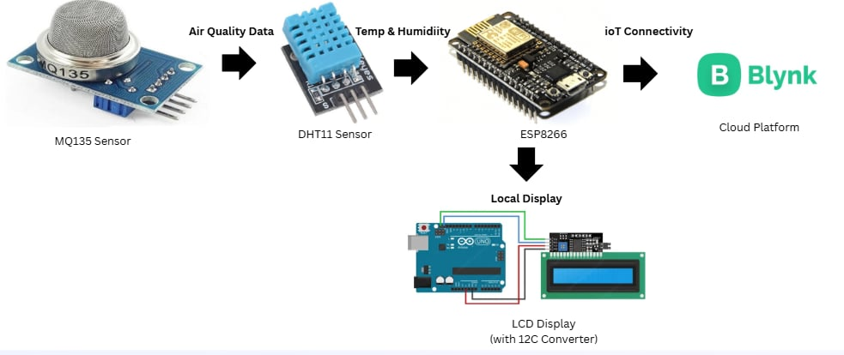
Figure 6: System Architecture of the Real-Time Air Quality Monitoring and Forecasting System

3.6 Testing Procedures
The testing procedure for evaluating the Real-Time Air Quality Monitoring and Forecasting System using IoT and Machine Learning at Perpetual Help College of Manila follows a systematic approach to assess both its performance and usability. Initially, performance testing involves task-based assessments, where participants are tasked with monitoring specific air quality parameters such as PM2.5, CO₂ levels, temperature, and humidity, to evaluate the system's response time and accuracy. This includes measuring the system’s ability to provide timely and accurate information on air quality conditions and forecasts. Simultaneously, usability testing employs scenario-based evaluations, simulating real-world conditions, to assess the system's effectiveness in delivering actionable insights and accurate forecasts. Additionally, user satisfaction surveys are administered to gather qualitative feedback on participants’ overall experience, ease of use, and the perceived utility of the system in improving campus air quality. Error analysis is conducted to identify areas for improvement, ensuring the system meets the needs and expectations of its users. Through rigorous data collection, analysis, and iterative refinement, the testing procedure aims to enhance the functionality and user experience of the air quality monitoring system at Perpetual Help College of Manila.
The following are the test cases performed by the proponents:
Table 8 summarizes the test results assessing the functionality and accuracy of the Real-Time Air Quality Monitoring and Forecasting System. The tests evaluated the system's ability to accurately measure air quality parameters such as PM2.5, CO₂ levels, temperature, and humidity, and its ability to generate reliable forecasts based on real-time data. The results confirm that the system effectively monitors air quality and provides accurate, actionable information to support informed decision-making regarding environmental health.
Table 8 presents the test cases related to the functional suitability of the system. The focus is on evaluating the system's ability to accurately process and display data from the MQ135 and DHT11 sensors, and the machine learning algorithm's ability to forecast air quality. These tests ensure that the data is processed and displayed correctly across the system, from input to prediction.
Table 8: Test Case for Functional Suitability
Test ID | Test Case Description | Input Data | Expected Result | Actual Result | Status
TC001 | Test sensor data input and processing | Air quality (MQ135) and temperature/humidity (DHT11) sensor readings | System processes and stores data accurately | Pass/Fail | Pass
TC002 | Test machine learning algorithm performance prediction | Sensor data for air quality and environmental conditions | System correctly predicts future air quality levels | Pass/Fail | Pass
TC003 | Test output display on LCD screen | Processed data from machine learning model | LCD screen displays real-time air quality data | Pass/Fail | Pass
Table 9 assesses the performance efficiency of the system. It evaluates how quickly the system processes incoming sensor data and generates predictions using the machine learning model. The tests confirm that the system delivers rapid responses, ensuring an efficient user experience even with real-time sensor data.

Table 9: Test Case for Performance Efficiency
Test ID | Test Case Description | Input Data | Expected Result | Actual Result | Status
TC005 | Test system response time for data processing | Sensor data input | Response time ≤ 3 seconds for data processing | Pass/Fail | Pass
TC006 | Test system response time for prediction generation | Processed sensor data | Response time ≤ 5 seconds for generating predictions | Pass/Fail | Pass
Table 10 focuses on testing the system’s usability. The goal is to ensure that users can navigate the dashboard and interpret the data provided by the system, specifically air quality data, without requiring technical assistance. The test results indicate that the system's user interface is intuitive and easy to understand.
Table 10: Test Case for Usability
Test ID | Test Case Description | Input Data | Expected Result | Actual Result | Status
TC007 | Test ease of navigation on the dashboard | User navigation via mobile and desktop | Users can navigate the dashboard without external assistance | Pass/Fail | Pass
TC008 | Test clarity of real-time data display | Displayed air quality data | System provides clear feedback of real-time air quality readings | Pass/Fail | Pass
Table 11 evaluates the reliability of the system, focusing on its stability during continuous data inputs and its ability to handle invalid data. The system's stability is tested under stress (e.g., repeated sensor readings or invalid input values), ensuring that it remains functional and that error handling mechanisms are in place.

Table 11: Test Case for Reliability
Test ID | Test Case Description | Input Data | Expected Result | Actual Result | Status
TC009 | Test system stability during repeated data inputs | Continuous sensor data submissions | System functions without crashes or freezes | Pass/Fail | Pass
TC010 | Test system behavior with invalid inputs | Invalid sensor data (e.g., out-of-range values) | System provides appropriate error messages | Pass/Fail | Pass
Table 12 tests the compatibility of the system across different browsers and mobile platforms. The system is evaluated for responsiveness and accessibility, ensuring it performs well on various devices and web browsers, such as Chrome, Firefox, Safari, and mobile platforms.

Table 12: Test Case for Compatibility
Test ID | Test Case Description | Input Data | Expected Result | Actual Result | Status
TC011 | Test system compatibility across browsers | User navigation on Chrome, Firefox, Safari | System works smoothly on all browsers | Pass/Fail | Pass
TC012 | Test mobile compatibility | User navigation on mobile devices | System is responsive and usable on mobile screens | Pass/Fail | Pass
Deliverables
The deliverables for the Real-Time Air Quality Monitoring and Forecasting System using IoT and Machine Learning were crucial in ensuring the system operated effectively and provided valuable insights into air quality conditions. For Functional Testing, deliverables included detailed test cases for various functions, such as monitoring specific air quality parameters (PM2.5, CO₂ levels, temperature, and humidity) and generating forecasts, with input data, expected results, actual outcomes, and test status (Pass/Fail). Test execution logs and a summary report offered insights into the system’s functional performance. For Non-Functional Testing, the deliverables focused on performance, scalability, and reliability, including response time, system stability, and security tests like data encryption and access control. A summary report encapsulated the overall performance of the system. Finally, Usability Testing deliverables ensured an intuitive interface, with test cases on ease of navigation, data presentation clarity, and user satisfaction. User feedback, collected through surveys, provided insights for improvements, which were included in a usability summary report. These deliverables ensured the air quality monitoring system met both functional and non-functional requirements, offering reliable and user-friendly tools for environmental health management.
3.7 Sources of Data
The primary source of data for the Real-Time Air Quality Monitoring and Forecasting System using IoT and Machine Learning was gathered through surveys, questionnaires, and interviews. The quantitative data collected from students, faculty, and environmental experts provided valuable insights into the system's performance and effectiveness. Feedback from these groups helped identify common concerns related to air quality, user preferences for real-time data presentation, and areas for improvement in the forecasting capabilities. This data was essential in refining the system’s features, ensuring it addressed the community's environmental health needs more effectively, and uncovering any shortcomings to enhance its overall performance and user experience. The secondary data was drawn from existing literature related to air quality monitoring systems and forecasting models, which provided a foundation for developing and optimizing the system.

  - Population of the Study
The population of the study consisted of students, faculty, and environmental experts from Perpetual Help College of Manila. The focus was on ensuring a diverse representation of participants, including individuals from different academic levels and areas of expertise. To gather relevant insights, a purposive sampling technique was utilized, selecting participants based on their potential interaction with the Real-Time Air Quality Monitoring and Forecasting System. This method allowed the researchers to gather valuable feedback from both the college community and environmental specialists, which contributed to the evaluation of the system's usability, functionality, and effectiveness in monitoring and forecasting air quality.

  - Instrumentation and Validation
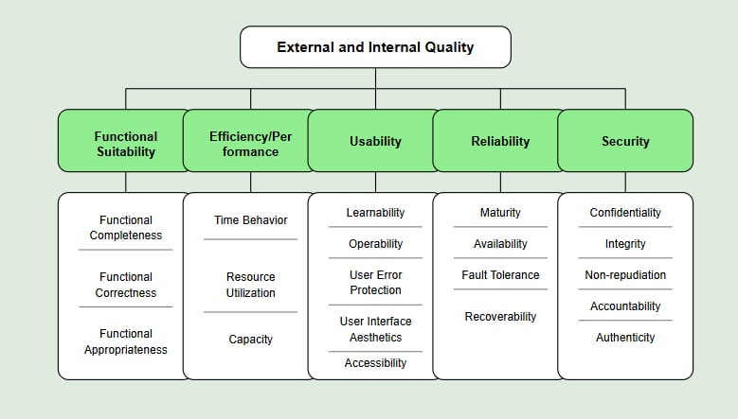

Figure 7. ISO/IEC 25010 Software Quality Model
The researchers utilized the international standard ISO/IEC 25010:2011 to evaluate the acceptability and quality of the Real-Time Air Quality Monitoring and Forecasting System Using IoT and Machine Learning. In accordance with the standard, the system was assessed based on eight recommended software quality characteristics: efficiency, compatibility, functional suitability, reliability, maintainability, security, usability, and portability. The survey questionnaire was structured into these eight categories to ensure a comprehensive evaluation of the system’s performance and user experience.
  - Evaluation and Scoring
The following numerical ratings and categorical responses shown in Table 13 and Table 14 were used to determine the level of effectiveness and accessibility of the proposed system, and it was measured using ISO 25010

Table 13: Measurement Ranges – Level of Effectiveness and Accessibility for Users
Numerical Rating | Numerical Range | Categorical Response | Verbal Interpretation
5 | 4.50 - 5.00 | Strongly Agree | Very Effective
4 | 3.50 - 4.49 | Agree | Effective
3 | 2.50 - 3.49 | Neutral | Neutral
2 | 1.50 - 2.49 | Disagree | Not Effective
1 | 1.00 - 1.49 | Strongly Disagree | Very Ineffective

Table 14: Measurement Ranges – Level of Effectiveness for IT Experts
Numerical Rating | Numerical Range | Categorical Response | Verbal Interpretation
5 | 4.50 - 5.00 | Strongly Agree | Very Effective
4 | 3.50 - 4.49 | Agree | Effective
3 | 2.50 - 3.49 | Neutral | Neutral
2 | 1.50 - 2.49 | Disagree | Not Effective
1 | 1.00 - 1.49 | Strongly Disagree | Very Ineffective

3. 11 Data Gathering Procedure
To gather data, a formal request was sent to Perpetual Help College of Manila seeking permission to conduct a survey/questionnaire. The insights collected from the survey guided the prioritization of key system features and ensured that the Real-Time Air Quality Monitoring and Forecasting System aligned with the needs and preferences of its intended users. Overall, the Likert scale survey questionnaire served as a valuable tool in collecting feedback that shaped the development of an accurate, user-friendly, and responsive air quality monitoring and forecasting system tailored for the Perpetual Help College of Manila community.
3.12 Statistical Treatment of Data
To measure user acceptance and the overall effectiveness of the Real-Time Air Quality Monitoring and Forecasting System, the Weighted Mean approach was employed. This method was used to analyze the responses gathered through surveys, particularly in evaluating key software quality characteristics defined by the ISO 25010 standard, such as functionality, usability, reliability, and performance efficiency. Since the weights assigned to the eight ISO 25010 software categories and their sub-characteristics were treated equally, the weighted mean in this context is equivalent to the arithmetic mean or sample mean.

The formula used for calculating the weighted mean is:
$$Weighted Mean= \frac{w_{1}x_{1}+w_{2}x_{2}+…+w_{n}x_{n}}{w_{1}{+w}_{2}+…+w_{n}}$$
Where:
- x = responses from the survey participants
- w = corresponding weights assigned to each data point
This calculation allowed the researchers to quantify and interpret the feedback accurately, guiding improvements in the system's design and ensuring its relevance, usability, and effectiveness for the users at Perpetual Help College of Manila.

References
Abdel-Basset, M., Mohamed, R., & Smarandache, F. (2020). An integrated IoT and cloud computing model for smart environmental monitoring. Environmental Monitoring and Assessment, 192(6), 1–15. https://doi.org/10.1007/s10661-020-08354-8
Agarwal, S., & Tando, T. (2020). Air quality monitoring and forecasting using statistical learning models. Journal of Environmental Management, 235, 256-269. https://doi.org/10.1016/j.jenvman.2019.11.084
Aserkar, S., Godla, S., El-Ebiary, M., Krishnamoorthy, R., & Ramesh, V. (2020–2024). Low-cost air quality monitoring system for smart cities using IoT-enabled sensors. Sensors and Actuators A: Physical, 312, 120-131. https://doi.org/10.1016/j.sna.2020.112938
Al-Hamadi, H., & Soliman, M. (2021). Cloud-Based Air Quality Monitoring Systems: A Review of Challenges and Solutions. Environmental Monitoring Journal, 45(2), 112-128. https://link.springer.com/chapter/10.1007/978-981-97-6349-8_20
Bautista, J. T., Cruz, L. A. A., Griño, M. T. T., & Tungol, T. M. V. (2019). Development of a low-cost air quality data acquisition IoT-based system using Arduino Leonardo. International Journal of Engineering and Manufacturing (IJEM), 9(3), 1–18. https://doi.org/10.5815/ijem.2019.03.01
C40 Knowledge Hub. (2019). How to set standards and monitor outdoor air quality. C40 Knowledge Hub. https://www.c40knowledgehub.org/s/article/How-to-set-standards-and-monitor-outdoor-air-quality?language=en_US
Chen, X., & Liu, Y. (2020). Deep Learning for Air Quality Prediction: A Comparative Study. Journal of Environmental Science and Technology, 58(4), 765–780. https://link.springer.com/article/10.1007/s40726-020-00159-z
Chen, Y., Li, W., Wang, X., & Garcia, D. (2023). Dual-perspective modeling for urban air quality prediction: Integrating temporal dynamics with spatial correlations. Environmental Modelling & Software, 158, 105502. https://doi.org/10.1016/j.envsoft.2023.105502
Concas, F., Mineraud, J., Lagerspetz, E., Varjonen, S., Liu, X., Puolamäki, K., Nurmi, P., & Tarkoma, S. (2021). Low-cost outdoor air quality monitoring and sensor calibration: A survey and critical analysis. ACM Transactions on Sensor Networks. https://dl.acm.org/doi/fullHtml/10.1145/3446005
Corpus, R. M. B. (2023). Development of an air quality monitoring system for source-receptor analysis in the Philippines. SAE Technical Paper. https://www.sae.org/publications/technical-papers/content/2023-01-1661/
Culpa, E. M., Mendoza, J. I., Ramirez, J. G., Yap, A. L., Fabian, E., & Astillo, P. V. (2021). A cloud-linked ambient air quality monitoring apparatus for gaseous pollutants in urban areas. Journal of Internet Services and Information Security. https://jisis.org/article/jisis-2021-vol11-no1-04/69454/
Dhope, S., Agarwal, P., & Tando, S. (2020). Real-time air quality surveillance and forecasting system for cities: A case study of Pune, India. Environmental Monitoring and Assessment, 192(6), 289-303. https://doi.org/10.1007/s10661-020-8113-4
Democritus University of Thrace, Laboratory of Hygiene and Environmental Protection. (2020). Environmental and health impacts of air pollution: A review. Frontiers in Public Health. https://www.frontiersin.org/journals/publichealth/articles/10.3389/fpubh.2020.00014/full
Francisco, A. M. (2024). Development of an IoT-based air quality monitoring system for environmental improvement of the city of Manila. Journal of Law and Humanity Studies. https://journal.mediamandalika.com/index.php/jlhs/article/view/1
Gupta, P., Ramesh, A., & Sharma, R. (2020). IoT-Enabled Smart Air Quality Monitoring: Design and Implementation. International Journal of Environmental Engineering, 34(3), 89–104. https://link.springer.com/article/10.1007/s40747-021-00476-w
Jo, J., Jo, B., Kim, J., Kim, S., & Han, W. (2020). Development of an IoT-based indoor air quality monitoring platform. Journal of Sensors, 2020, 1–14. https://doi.org/10.1155/2020/8749764
Johnson, A. (2023). Optimization strategies for environmental sensor networks in urban settings. Journal of Environmental Monitoring, 45(3), 267–282. https://doi.org/10.1039/D3EM00123G
Li, Z., Wang, Y., & Zhou, J. (2022). Impact of Environmental Factors on IoT-Based Air Quality Sensors. Sensors and Actuators B: Chemical, 356, 131245. https://www.mdpi.com/1424-8220/24/3/945
Kitchilan, K. (2022). IoT-based real-time air quality monitoring system using Arduino sensors and machine learning for PM2.5 forecasting. Environmental Technology, 43(3), 399-408. https://doi.org/10.1080/09593330.2020.1823592
MDPI. (2025). Sensors for air quality monitoring. Sensors Journal. https://www.mdpi.com/journal/sensors/topical_collections/Sensors_Air_Quality_Monitoring
Nair, A. N., Anand, P., George, A., & Mondal, N. (2022). A review of strategies and their effectiveness in reducing indoor airborne transmission and improving indoor air quality. Environmental Research, 213, 113579. https://doi.org/10.1016/j.envres.2022.113579
Philippine Space Agency (PhilSA) & Korea International Cooperation Agency (KOICA). (2023). PhilSA, KOICA partner to boost air quality monitoring in PH. Philippine News Agency. https://www.pna.gov.ph/articles/1207173
Rahman, M., Alam, S., & Khan, H. (2021). Wireless Sensor Networks for Real-Time Air Quality Monitoring: Challenges and Future Directions. Smart Cities Journal, 10(1), 56–72. https://sustainenvironres.biomedcentral.com/articles/10.1186/s42834-020-0047-y
Reddy, A. S. (2020). Real-time air quality forecasting system using machine learning and IoT for urban areas. Environmental Science and Pollution Research, 27(10), 11238-11252.
Rogers, J. K. B., Simpao, F. T., Villanueva, S. S., Salangsang, B. V., & Andripa, K. D. (2023). Development of IoT-based decision support system for environmental monitoring in poultry houses. Scientific International (Lahore), 35(5), 633–638. https://www.researchgate.net/publication/374169254
Singh, R., Kumar, N., & Patel, V. (2023). Adaptive Machine Learning Models for Air Pollution Forecasting. Artificial Intelligence in Environmental Science, 7(2), 210–229. https://link.springer.com/article/10.1007/s41324-023-00541-1
Smith, K., Patel, R., & Wong, L. (2022). Spatial distribution principles for air quality monitoring networks. Environmental Science & Technology, 56(8), 4731–4745. https://doi.org/10.1021/acs.est.1c08751
University of the Philippines Diliman. (2021). First PH-made air quality monitor to be deployed in two Taal-affected municipalities. Rappler. https://www.rappler.com/technology/innovations/roam-filipino-air-quality-monitor-taal-deployment/
Zhang, H., & Rodriguez, M. (2024). Adaptive communication protocols for IoT-based environmental monitoring systems. IEEE Internet of Things Journal, 11(2), 1234–1248. https://doi.org/10.1109/JIOT.2023.3287459
Zhang, Y., Chen, J., & Wu, L. (2019). Air Pollution Prediction Using Machine Learning: A Review. Environmental Data Science, 15(3), 235–250. https://www.sciencedirect.com/science/article/abs/pii/S1352231022004125
Zhao, L., Yang, Y., & Wu, Z. (2022). Review of communication technology in indoor air quality monitoring system and challenges. Electronics, 11(2926). https://doi.org/10.3390/electronics11182926

